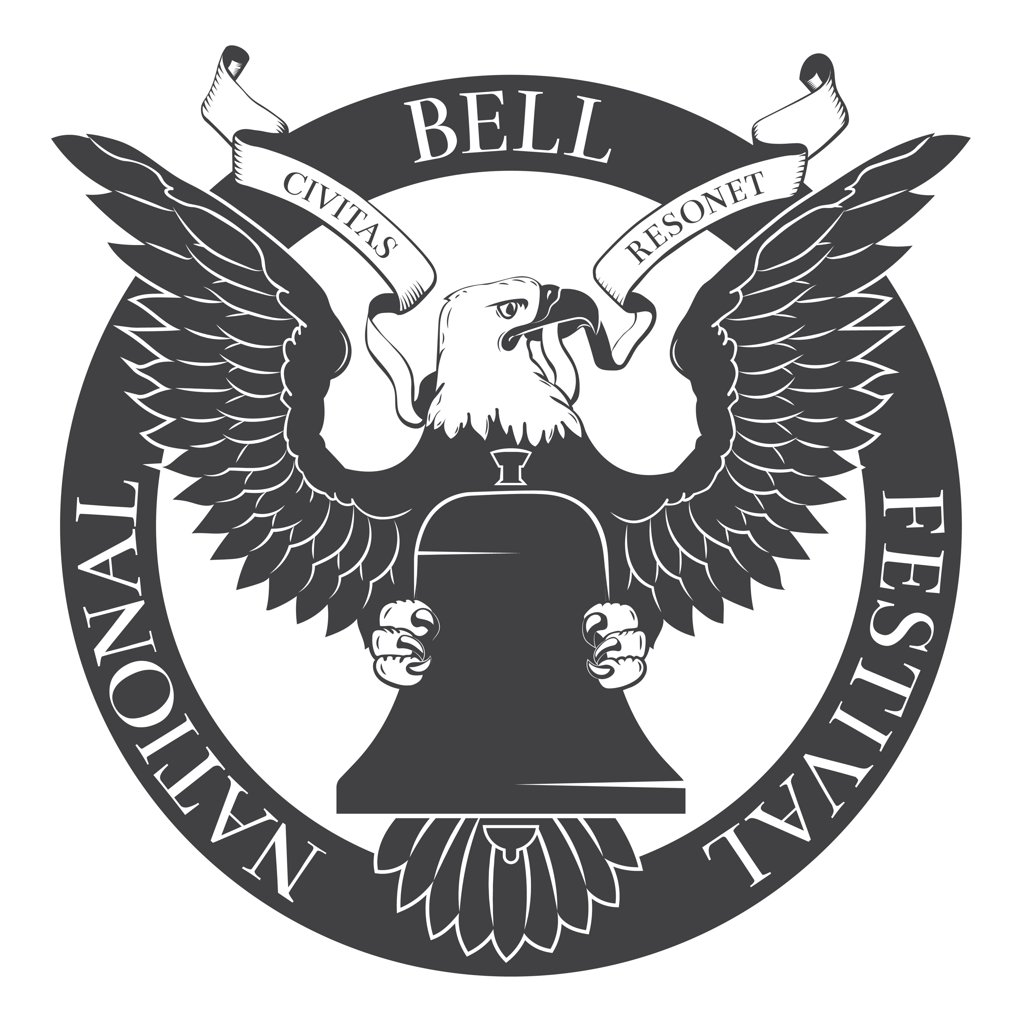

Register a Bell

The history of our nation is written in bronze. Help us toll the story. We're compiling the fascinating records and narratives of bells across America. If you know about a bell in your neighborhood, share your story with us!

- This is a single bell.
- This bell is part of a group of bells or carillon.

This form is not meant to capture data on handbells.

Your Information
---
Organization name:
Contact name:
Phone:
Email:
Website:

Bell Information
---
Where is the bell located?
Please provide the location name (e.g. Springfield Town Hall) and its address.
Describe the bell’s location within the property.
Does the bell have a name?
e.g. Liberty Bell
Does the bell ring?
If yes, please detail when.
Foundry / Who created the bell?
e.g. Whitechapel Bell Foundry, Taylor's of Loughborough
In what year was the bell cast?
What is the bell made of?
e.g. bronze, iron
The bell is tuned to…
e.g. G#
How heavy is the bell (lbs.)?
What is the bell’s diameter at its mouth (inches)?
Is anything inscribed on the bell?
Was this bell created for a special occasion, commemoration, memorial, or recognition?

If this bell is part of a carillon…
---
How many bells compose the full set?
Is the instrument played manually or automatically?
Who is the head carillonneur?

Additional Information
---
Is there anything else we should know?

Attachments
---
Suggested items to include:
- Map of bell location and sound radius
- Bell and bell tower images

Copyright © 2020 The National Bell Festival, Inc., a registered 501(c)(3) charitable organization.

