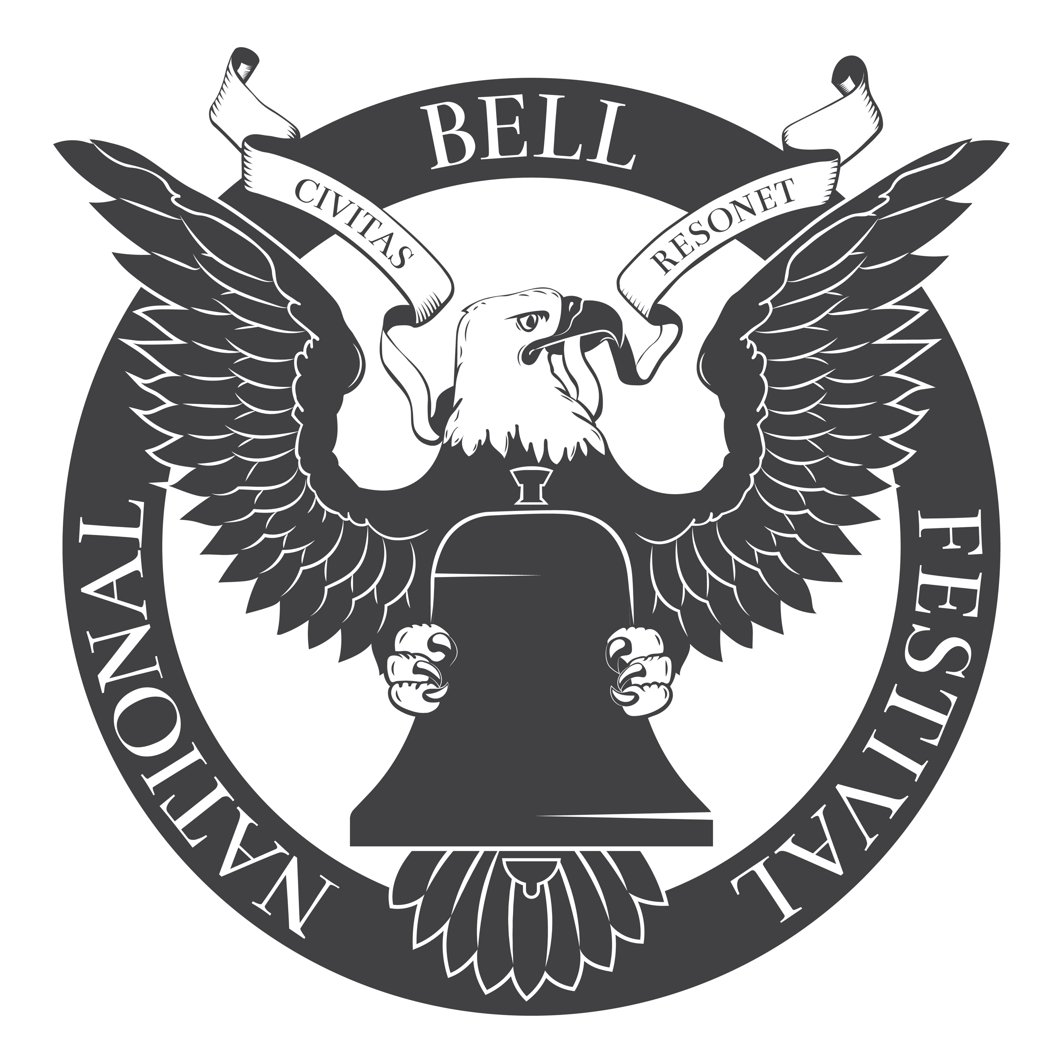

Application for Support

Organizational Information
---
Organization name:
Briefly describe the organization’s history and purpose.

Tax ID:
Is this organization a not-for-profit 501(c)3?
Contact name:
Address:

Phone:
Email:
Website:

Bell Information
---
Briefly describe the history of the bell (size, age, casting, historical importance, melodic tuning, etc.).

Describe the bell’s location within the property and the public’s access to it.

What is the sound radius of the bell?

Condition of the bell. Describe repairs needed.

Condition of tower. Describe repairs needed.

Restoration Plans and Amount of Request
---
Have you contacted a restoration specialist?
If yes, please provide their contact details.

Please describe any existing restoration plans, or those provided by architectural or construction firms.

What is the anticipated cost for repairs and refurbishment?
Please detail exactly how the funds will be used.

What is your anticipated timeline for the project?

What existing fundraising or funding channels do you have for this project?

How much additional/supplemental funding are you requesting from the National Bell Festival?

Additional Information
---
Is there anything else we should know?

Attachments
---
Suggested items to include:
- Map of bell location and sound radius
- Existing plans and architectural proposals
- Budget breakdown
- Bell and bell tower images

Copyright © 2020 The National Bell Festival, Inc., a registered 501(c)(3) charitable organization.

